Wath Central Primary
Prospectus 2019 - 2020

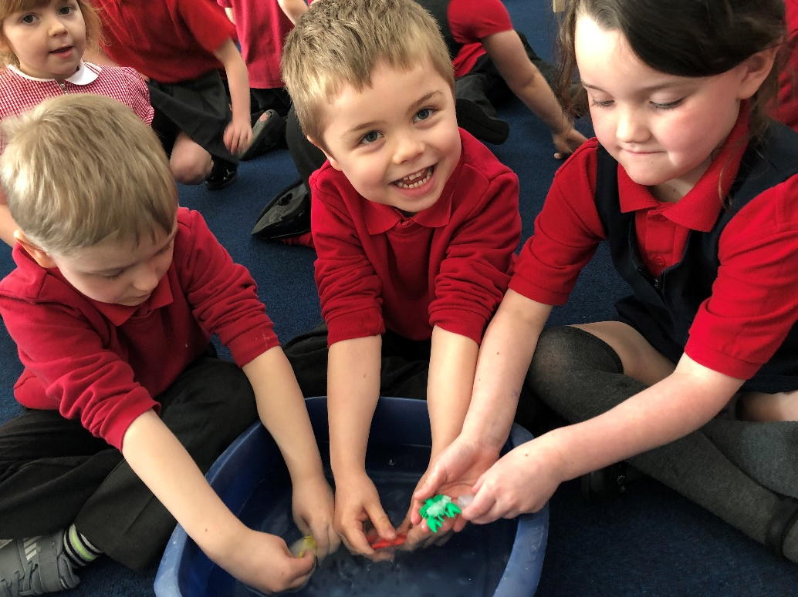

WELCOME FROM THE HEADTEACHER

On behalf of the children, staff and governors of Wath Central Primary School, I would
Like to warmly welcome you and thank you for enquiring about our school.
​
We are extremely proud of our school and as a staff team, we are committed to providing the very best education for all the children in our care. Our work is formed and led by our shared mission and vision (see below).

Wath Central is a family; children are at the centre of everything we do. We are a welcoming and caring school; we work together as a community to provide a happy, safe and secure learning environment where each child is a valued individual, with their own strengths and development needs. We promote mutual respect for each other, we value diversity and continually seek to remove barriers to learning.
We strive for excellence. We strive for every child to reach their potential as successful l earners, confident individuals and responsible citizens. We promote education as an experience to be embraced as well as enjoyed, allowing the learner to achieve beyond their expectations. We aim to stimulate and excite the children's imagination, motivate a desire to achieve and inspire a lifelong love of learning.

If you would like to know more or if you would like to visit us, please do contact us. We would love to hear from you! Ms Jude Gray
Together, we can.

Wath Central is a day primary school (mixed) offering places for children aged between 3 and 11 years old.

Children enter our Foundation Stage One in the year of their fourth birthday and Foundation Stage Two in the year of their fifth birthday. Children of mixed ability are organised into classes, according to age and with a reasonable balance of boys and girls. Foundation Stage classes are normally set at around 25, with classes in Key Stage 1 set at 30. The school has capacity for 472 children overall.

OUR MISSION
We value every child for what they are and prepare them for everything they could be.
This is a place where everyone is valued and cared for as an individual, their views and heritage are respected.

As a school, we want our children to make a difference in our community and during their lifetime. We want them to develop a curiosity for the world in which they live, a love of learning and be able to work collaboratively whilst expressing their individuality with confidence. In this way, we encourage our learners and staff to question the purpose of the learning and develop projects which will have an impact.

OUR VISION
For us, education is about making memories and fulfilling dreams; it’s about children acquiring the knowledge and skills to prepare them for their journey as life long learners, intellectually, physically, socially, emotionally, morally and spiritually. It’s about the joy of discovery and the expression of individuality.

We want our children to feel safe and happy, enabling the uniqueness in each individual to flourish through a calm and supportive environment that allows them to flourish and exceed their own expectations

We want to develop in our children the confidence, independence and self-esteem of every child in our care, so that they are equipped to live as global citizens in our fast changing world. We want them to understand their role and responsibilities in the community and to work together regardless of age, race, gender, culture, religion and disability in an environment where diversity and inclusion go hand in hand.

We want our children to be committed to learning, to be positive enough to see challenge as an opportunity and mistakes as valuable

We want our children to experience a curriculum that inspires and empowers them to be curious about the world; and to be brave enough to explore ideas and to question why. We want our children to be filled with awe and wonder, to think creatively and use the power of their imagination.
For us it’s about togetherness. It’s about inspiring a community to achieve success.

ATTENDANCE
What the school expects of pupils:
• To attend regularly
• To arrive on time, appropriately prepared for the day
• To report to the class teacher

What the school expects of parents/carers
• To fulfil their responsibility by ensuring their children attend school regularly and on time
• To ensure that they contact the school on the first day their child is unable to attend by 9:15am
• To ensure their child arrives on time and is well prepared for the school day (rested, fed, appropriately equipped and prepared etc.)
• To contact the class teacher or Head teacher in confidence whenever any problem occurs that may keep their child away from school
• To inform the class teacher and/or admin assistants and seek authorisation for any forthcoming appointments and, where possible, arrange appointments outside of the school day
• To ensure the continuity of their child’s education by taking holidays during the school holiday period and, in exceptional circumstances where this is not possible, to request leave in term time by completing the application in advance of the holiday

What parents and pupils can expect of the school
• A broad and balanced education that is dependent on regular and punctual attendance at school
• The encouragement and promotion of good attendance
• Regular, efficient and accurate recording of attendance
• First day contact with parents when a pupil fails to attend school without providing good reason
• Prompt action on any problems notified
• Close liaison with our Pastoral team and linked agencies who can provide Early Help support within school or refer to Local Authority level to assist and support parents and pupils where needed
• Notification to parents/carers of their child’s unauthorised attendance record through annual reports home

Illness
We request that children who are clearly not well should not be sent to school. If your child is absent from school through illness, please contact the school office by telephoning before 9:15a.m stating the reason for absence. If we have not received a phone call, and your child is not in school, we will contact you to enquire about the whereabouts of your child.

If a child should be taken ill at school every effort will be made to contact the child’s parents/carers as soon as possible. Therefore it is essential that we have current emergency contact details for yourself and another named person who could collect your child.

Medical Appointments
Parents are requested to notify the school office if they wish to collect their child from school for an appointment. Children will only be allowed to leave school if collected by their parent or authorised adult from the office. Your child will then be ‘signed out’ of school. Please note that this does affect your child’s attendance.

Every effort should be made to arrange appointments before or after school. If your child has an appointment during the morning or afternoon, it is expected that your child will come in to school to be registered before leaving for their appointment.

Holidays in Term Time
Legislation dictates that Headteachers are unable to grant any leave of absence during term time unless there are exceptional circumstances In such circumstances, you should contact the Head teacher who will discuss the definition of exceptional circumstances. Evidence will be needed.

If you take your child out of school during term time, without the schools authorisation, the Headteacher will make a request to the Local Authority to issue a Fixed Penalty Notice.

Registration Procedure
• Registration begins at 8.55 am (parents/ carers can join children from FS to Y3 in the classroom for a ‘morning task’ prior to registration from 8.45 a.m.)
• Class teachers will insert a mark for every pupil whether it is a present mark or an absent mark. All marks will be made accurately in accordance with computerised registration systems
• Staff will be in their classrooms at the start of the Registration period
• If pupils arrive after 8.55 am they will be deemed to be late
• The register is closed immediately after registration and will only be reopened classroom for afternoon registration.

If children are absent for one reason or another, they must not return to school in the middle of the lunchtime period i.e. 11:45 – 12:40 (KS1) and 12.15 – 1.15p.m. (KS2)

Responding to Lateness
• Pupils arriving after close of register in the morning or afternoon should report to the school office.
• Good attendance and punctuality will be recognised.

BEHAVIOUR IN SCHOOL
At Central, we believe in a pupil centred holistic approach based on positive relationships. We take our responsibility for our children’s behaviour very seriously and we like to work alongside parents and the community to encourage our children to develop personally, socially and academically and to this end we concern ourselves with respect; understanding their thoughts and feelings –getting to know them as people. We seek to provide security, safety and acceptance in a physically and emotionally safe environment. We seek to listen and communicate; understand the behaviour rather than to merely react to it.

All children want to learn and children learn best in a stimulating, harmonious classroom and school supported by a team, a community, around them. We aim to promote good behaviour at Central by:
- Forging positive relationships with all our children – getting to know them as people
- recognising good behaviour as it occurs and praising all children for behaving well (we praise in public and reprimand in private).
- modelling the behaviour we expect to see and giving clear, concise instructions
- encouraging children to be responsible for their own behaviours
- letting parents know about children’s good behaviour

Discouraging inappropriate behaviour. If the contract of behaviour is persistently or seriously breached, it may be appropriate to take sanctions. These may include:
- reminding children of appropriate behaviour
- allowing the child time and space to calm down, before supporting them to self regulate, repair and take part in a restorative conversation
- If necessary, the child may work separate within the class or in out of class learning spaces to allow space.
- removing privileges
- contacting a parent to discuss ways of improving behaviour.
- referring a child to the Senior Leadership team, Safeguarding and Inclusion manager, Learning Mentors and Headteacher who will take appropriate action such as setting up a system of reporting to a member of senior leadership team regularly, designing a bespoke behaviour plan, seeking advice for external agencies etc. Exclusion is he very last resort when resources in school have been exhausted and the child is a significant risk to themselves or others.

NURTURE PROVISION
The nurture provision is an invaluable resource at Wath Central. It provides a link between home and school and offers children a place where they can feel safe and confident to explore their emotional and social wellbeing. Within the provision they have an opportunity to learn about themselves and others in order to develop and grow as resilient individuals.
Our two nurture rooms, The Den and the Chillax Room, form the base for our nurture work which is carried out throughout the school day. The outside environment, including the nature garden and wilderness area, are also used when delivering interventions. Children access the provision both on a one-to-one and small group basis in order to carry out work to support their individual requirements. Sessions are fun and informative, using activities and resources to motivate, engage and support the children. Before children attend nurture provision parents are requested to sign a permission slip and specific assessments using PIVATS will be carried out to ensure that the children are receiving the specific intervention they require.
- We deliver a number of interventions to support children for specific reasons, for example:
- Friendship difficulties – keeping/making friends
- Anxiety or excessive worrying
- Understanding and regulating emotions
- Developing relationships - both friendship and sibling relationships
- Bereavement
- Family Break up

BULLYING and RACIST BEHAVIOUR
We are very concerned for each child’s well-being and cannot and will not tolerate bullying or racism. If there are any instances where a child is being upset in this way, please make sure that we are informed immediately so that help and advice can be given and problems solved before the issue becomes even more serious. We do have strategies in school aimed at eradicating any issues.

WORKING IN PARTNERSHIP - PARENTAL HELP AND VISITING SCHOOL
Parent/Teacher/Child relationships are regarded as very important to the school. Parents are welcome to see teachers at the end of the day and to make appointments at any time to discuss any issues which have arisen. We aim to keep parents well informed of their children’s progress or problems at all times. If you have any concerns or questions, please do not hesitate to ask. Parents’ consultation days are held twice during the year, following which a summary report of progress is given. An annual Record of Achievement is sent out during the Summer Term and there is an opportunity to meet the new teacher in July and September.

Parents are also invited to a number of other events during the year, for example curriculum / project days, sports events, music and drama celebrations, and topical special events. Close links are maintained with Wath Central Infant School, Oakwood High School and other local secondary schools so that the transition periods at the beginning and end of Key Stage Two are made as smooth as possible.

SCHOOL ROUTINE
Foundation Stage 1
Sessions for Foundation Stage 1 children (Nursery) run from 8.45a.m – 11.45a.m or 12.15 – 3.15p.m. Monday to Friday. Children attend either session all year. A facility exists for a fixed number of children to attend full days. If eligible for funding, parents may take advantage of a full 30hrs provision if their child attends our Nursery, where places exist. Foundation Stage 1 has it’s own entrance to the left of the main entrance of school. Parents are welcome to join in the first task of the day when dropping off a child for their session.

Foundation Stage 2 and Key Stage 1 (Year 1 and 2)
Doors open at 8:45am and registration is at 8:55am. A morning task is available for all children and parents are welcome to come in and support their children with this in FS1 to Y3 (Y2 and Y3 - during the Autumn term, FS and Y1 – all year). Year 1 enter through their classroom doors and FS2 and Y2 enter through the old entrance.

Lessons begin at 9:00am and finish for lunch at 11:45am. During the morning, there is a scheduled break of 15 minutes for Years 1 and 2. Foundation Stage children have access to their outdoor space at various times during the day but due to the nature of their curriculum, do not have scheduled ‘break’ as such. Afternoon lessons resume at 12:40pm and the school day finishes at 3:00pm. Teachers in Years 1 and 2 may decide to take an afternoon break when and if appropriate on the day.

Key Stage 2 (Years 3 to 6)
Doors open at 8:45am and registration is at 8:55am. A morning task is available for all children and parents are welcome to come in and support their children with this in Y3 during the Autumn term. All classes enter through their classroom doors. Lessons begin at 9:00am and finish for lunch at 12:15pm. During the morning, there is a scheduled break of 15 minutes split across the Key Stage so that no more than two year groups are out together. Afternoon lessons resume at 1:10pm and the school day finishes at 3:15pm. Teachers may decide to take an afternoon break when and if appropriate on the day.

It is essential that children arrive on time for each session in order to get off to a prompt start.
Supervision of pupils on school premises is available from 8:40am and, for safety reasons, pupils should not arrive earlier than this. Children who arrive late face great difficulties as the first few minutes set the tone for the rest of the day.

Children are encouraged to drink water during the day. Fresh, chilled water is available to all pupils. Please equip your child with a lidded, named, plastic drinks container for this purpose. Children in the Foundation Stage are provided with free milk and fruit/veg choice daily. Water is also readily available. Free fruit/veg continues until the end of Year 2.

CURRICULUM
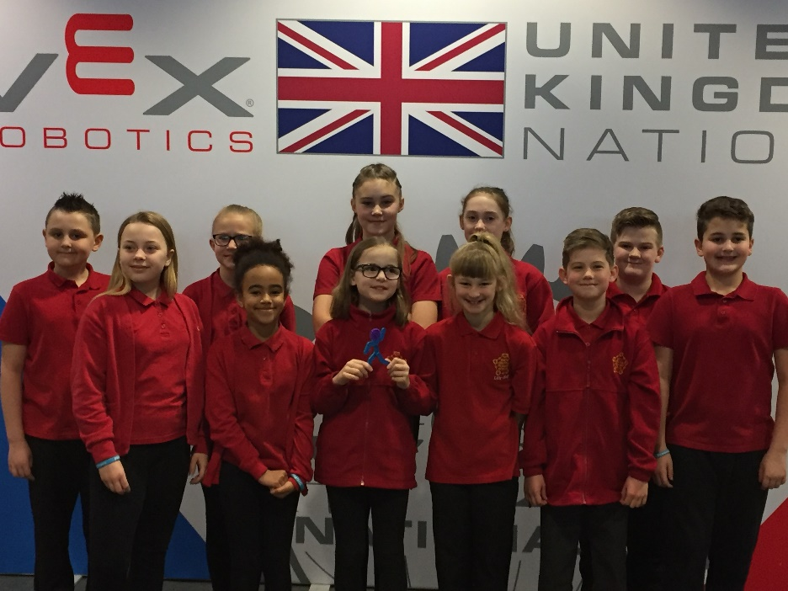

Values led curriculum
Our values are threaded through everything we do at Central. We strongly believe that by encouraging, sustaining and enhancing these values, we can achieve the highest possible standard for every child in our school. We aim to:
BE SAFE. BE WELL
Be kind; be respectful
Be responsible
Be proud
Be creative
Be resilient
Be reflective
Be aspirational

Foundation Stage
High quality early years’ experience is of vital importance and has a lasting effect on a child’s attitude to education, personal and social skills and attainment. First days at school for young children (and families) trigger a mixture of all kinds of emotions. The school day and its demands can be quite daunting and, at first, very tiring. Children and their parents/carers are invited to spend some time with us during the three induction days in June/July but also we can design a further, bespoke transition for any children requiring this and to ensure that we are meeting your child’s need. Similarly, if any children are unsettled during transition and require further informal visits, we can accommodate this as well.

An induction evening is also held for the parents of our new intake. This meeting outlines the induction process and gives parents a chance to meet the staff and find out anything they want to know about education at our school. The meeting is intended to be informal, with plenty of opportunities for questions and comments.

The Foundation Stage curriculum follows the new Statutory Framework as implemented from September 2012. All areas of the curriculum are covered both inside and outside, and contain seventeen goals for the children to work towards. The children build up a variety of evidence showing some examples of their work and photographs of some of their other activities, which contribute to the teachers’ assessments of each child. Regular updates about the child’s progress are communicated with parents as well as informal updates on collection and via Dojo (our electronic communication system). Parents are strongly encouraged to share learning from home with school as well.

Years 1 to 6
The National Curriculum is taught from Years 1 to 6. Our teachers work hard to ensure the curriculum is as stimulating and exciting as possible, so that the children enjoy learning and are inspired to become lifelong learners. We build in many links with the local area and take the children on a variety of educational visits, to excite and interest them in their learning and to create a real life context to learning. Our aim is to deliver our creative curriculum in a cross curricular way. Within each theme of work maximum opportunity will be taken to integrate cross curricular links, with literacy and numeracy at the core.

ENGLISH
English is taught in an exciting, stimulating and enjoyable way. There are 4 main elements to the English curriculum - Spoken Language, Reading, Writing and Grammar, Punctuation and Spelling. Our stimulus for much of our learning is a book which we explore as a reader and as a writer. Sometimes this book is a vehicle for the whole topic and learning across the wider curriculum too, as well as being a starting point for big questions about the world.

Speaking and Listening
Development of children’s speaking and listening skills are vital, particularly in their early years. Children are encouraged to develop a love of listening to stories and poems, saying rhymes, as well as participating in drama and role play – all of which help to develop their listening and speaking skills. They become confident, fluent and articulate, and very able to express themselves. We encourage all children to be interested in other people’s thoughts and feelings, ideas and opinions, and value and respect them. We have a strong, established link with the Speech and Language team in Rotherham for those children who require specific support in their development.

Reading
We are committed to providing a rich and comprehensive reading programme, offering a range of opportunities to become fluent, enthusiastic readers. A wide range of reading experiences is offered through the Literacy lesson and during continuous provision.

Phonics
Phonics forms the daily basis of reading development in EYFS and KS1 and this approach to teaching reading is taught daily in every class. Phonically decodable reading books, as well as simple fiction and non-fiction books, are used to support children’s early reading skills within school.

Individual and Guided Reading
Individual and guided reading usually takes place twice a week. Children read individually or within a group with others of similar reading ability. The book is specially chosen to match the reading ability of the child or group. During the session, we teach appropriate reading strategies or skills to support children’s decoding and understanding of a text. Guided reading provides opportunities for children to take part in discussion where they can enthuse and learn from each other.

Writing
Much of the writing is cross-curricular in nature covering a range of genres, giving children a real purpose and context in which to write. Writing can be produced individually, as a pair or in groups with a range of inspirations to reflect the wide variety of reasons to write in everyday life. Attention to grammar, punctuation and spelling is thorough within the daily Literacy session but specific aspects are taught separately, where appropriate.

Stay and Learn Sessions
We hold regular sessions, during the daytime and evening, for parents to attend to give you the opportunity to find out how we teach different subjects; meet the teachers and gain advice about how to support your children’s learning at home.

Maths
We inspire all children to become confident and enthusiastic mathematicians, who are willing to take risks and are not scared of making mistakes. We teach children that an important aspect of their development is to learn from their mistakes. We aim to develop a range of mathematical skills and provide opportunities for their application in meaningful, real-life situations. We strive to provide our children with exciting and challenging investigations, thereby increasing motivation and promoting a positive response to mathematics.

Science
Science is taught in every year group through school and children develop both their knowledge and skills as scientists. The development of children’s experimental and investigative skills is key. Children are encouraged to be independent and collaborative scientific investigators by their involvement in exciting practical investigations. Investigative work takes the form of modelled and independent investigations and the proportion of these skills varies between year groups. The new curriculum also recognises the importance of a developing knowledge of scientific concepts. Our lessons incorporate both knowledge and investigative skills through a lively and creative curriculum.

Art
Art is a useful means of expression, and is linked with many other areas of the curriculum. All children have experience in using a variety of media including paint, pastel, clay, fabrics and sewing. They produce both 2D and 3D work. During art lessons, children are encouraged to talk about their observations, so developing their use of language. They study work by famous artists and imitate those styles in their own work. We also encourage the children to identify art in the local environment, and value each other’s work. We believe strongly in children working from first-hand experience, so make use of many artefacts, visits and natural objects.

Design & Technology
Children learn how to think imaginatively, and talk about what they like and dislike when designing and making. They build on the experience gained in the Early Years through investigation and play. They explore how familiar things are designed and how they work. They talk about, draw and model their ideas. The children learn how to use tools safely, to use ICT as part of their designing and making and to consider the health and safety aspects of food technology.

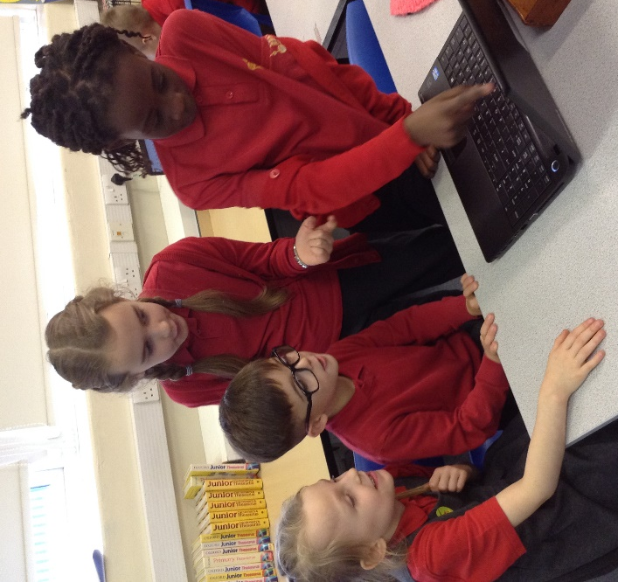

Computing
Computing is a new aspect of the Primary National Curriculum, where children develop an understanding of computer science as well as equipping them with the skills to use a range of Information and Communication Technologies to create programs, write texts and store information.

Technology is used to enhance the teaching and learning across the curriculum and to motivate and engage the children at every possible opportunity.

Music
From an early age, children experience music in various forms; for example nursery rhymes, background music, songs and games. Our aim to nurture and build on these experiences in order to develop an understanding and enjoyment of music. Children are given opportunities to sing, play a variety of simple percussion instruments, explore sounds, compose, perform and listen to music from a range of times and cultures. Children perform in school several times throughout the school year, and also take part in singing for the wider community at various events.

Families of older children also have the opportunity to purchase individual or small group session in order for their child to learn woodwind, guitar and drums.

A teacher from Rotherham Music works with one year group from KS2 to develop rhythm using Djembes and other percussive instruments. Drumming naturally creates a sense of belonging and community and this links to our values led curriculum too.

Geography and History
Here we strive to ignite a curiosity and develop their understanding of the world in which they live, why it is as it is and how they can influence the future. This begins with a secure understanding and awareness of chronology and the passing of time. We want the children to understand local, national and world events from the past which have had an impact on their lives.

The children explore why people did things, research causes and make links between events: begin to explore bias and historical interpretation. The children will have opportunities to explore and question a range of primary and secondary historical and geographical sources and develop their skills of organisation, communication and representation. The children will study the lives of significant men and women in the past who have contributed to national and international achievements and discuss changes that have happened over a period of time. The children also gain historical perspective by placing their growing knowledge into different contexts undertaking studies about the British values of democracy, individual liberty, the rule of law, mutual respect and tolerance of other faiths and beliefs.

We strive to stimulate their enquiry and deepen their understanding by arranging historical and geographical educational visits and visitors allowing access to high quality first hand experiences.

Religious Education and PSHE
Religious education and Personal, Social and Health Education cannot be separated from children’s learning about their environment and their relationships with others. We encourage our children to care for and respect the work, feelings, faiths and possessions of other people, and we hope that the ordering of our school life will lead to co-operation and friendship with each other. Through assemblies, stories, visits and visiting speakers, children develop a deeper appreciation of the spiritual, moral and natural world around them.

SMSC & British Values Within our creative curriculum, fundamental British Values are promoted and discussed so that the children can be prepared for life in modern Britain. This enables children to develop a strong understanding of Democracy, The Rule of Law, Individual Liberty, Mutual Respect and Tolerance of those with different faiths and beliefs.

Spiritual development encourages the children to reflect on their beliefs, religious or otherwise, and reflect on their experiences, and to try and answer some of life’s fundamental questions. The use of imagination, creativity, and a sense of fascination in learning about themselves and the world around them is developed.

Moral development encourages the children to recognise the difference between right and wrong; to have a concern for others and to begin to understand the consequences of their actions. They are helped to think about moral and ethical issues and to think about the views of others in these matters.

Social development encourages the children to work and socialise with others and to relate to those from different backgrounds; religious, ethnic and socioeconomic, and they are helped to understand and accept the British Values in order to participate fully and contribute positively to life in modern Britain.

Cultural development encourages the children to understand and appreciate the wider range of cultures in their local community and further afield. They are taught to respect different faiths and diversity in local, national and global communities. The children are also encouraged to take part in artistic, sporting and cultural opportunities.

Physical Education
All children take part in at least 2 hours of P.E. per week; one of which is outside (weather permitting), with other lessons delivered in the hall. Teachers structure P.E lessons as they would any other lesson with appropriate questioning, challenge and support given to the children.
PE Kits should consist of: white T-Shirt, black shorts/jogging bottoms/leggings, black jumper and trainers/pumps. P.E Kits should not involve wearing any items worn through the day as uniform. Long hair must be tied back.
No earrings should be worn for PE, unless they cannot be removed by the pupil themselves. If they cannot remove their earrings then they should be covered with tape. This needs to be one by the pupil themselves, with tape provided from home (not plasters from school). Earrings must not be worn at all for school swimming lessons.
No other personal items are to be worn. This includes fitness tracker watches such as Fitbit. Children should not be wearing necklaces, bracelets, rings etc at anytime as it is not part of our uniform policy.
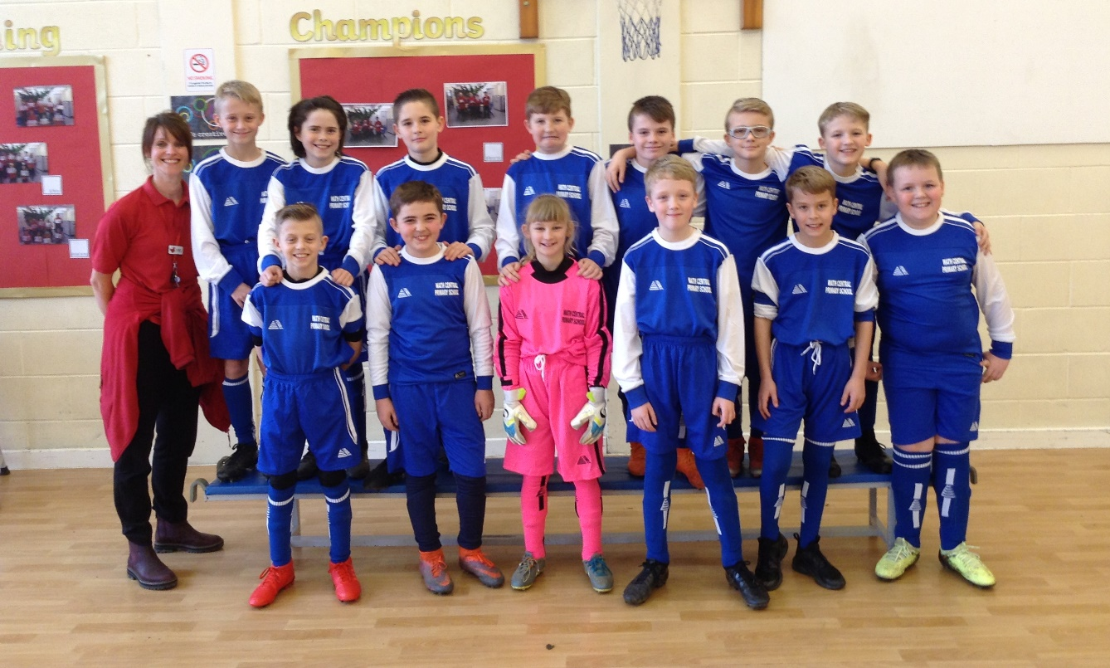
LEARNING AT HOME
Every child is issued with a reading card. There is an expectation that children will read four times per week at home to an adult or older sibling. Reading cards are checked by school staff each week and children have the opportunity to change their book at this time. There are regular opportunities to change books in school. We encourage you to help to develop comprehension skills and the love of reading through regular reading.

We actively encourage learning at home and provide links to a number of websites including Times Table Rock Stars within our Learning At Home policy. We encourage regular practice of tables and spellings.

Each term the year group team will send out a newsletter which will include details of a choice of home learning projects linked to that half term’s topic. Children are asked to choose at least one to suit their particular interests and talents. These should be completed and returned by the deadline given and these will be celebrated in class.

SPECIAL EDUCATIONAL NEEDS
SEND
At Wath Central we are passionate about providing the best possible education for all our pupils, including those with additional needs, to enable them to reach their true potential and develop as individuals. We aim to reduce barriers to learning and are committed to providing opportunities and support to enable pupils with SEND to successfully access a real and meaningful curriculum appropriate to their needs. Children’s mental health and wellbeing is paramount. Our nurturing approach offers a range of opportunities for children to engage with activities and experiences, giving them the social and emotional skills to do well at school both socially and academically. We equip them with skills to develop their resilience and their capacity to deal more confidently with the trials and tribulations of life. We believe in the earliest possible intervention in order to support children with specific requirements and understand that the liaison between parents/carers is crucial to making this a success. We highly value the partnership between home and school and welcome collaborative working in order to best support our pupils.

If you would like to know more about our SEND and nurture support or if you would like to visit us, please feel free to contact us. We would love to hear from you!

Accessibility
A clear accessibility plan is in place in school to ensure that we consider the needs of all people with disabilities. We operate a fully inclusive policy in our school, catering for pupils with very diverse needs. The school has a facility for allowing access to the full site using ramps and lifts, and we have an accessible toilet with hoist. Parents with disabilities are encouraged to let the school know if there is any way we can make communication between home and school easier for them.

SCHOOL SERVICES
SCHOOL MEALS
School meals are cooked on the premises and are served cafeteria-style. They offer a nutritious, hot and well-balanced meal. There is a wide and varied choice of menu and year groups take it in turn to go into the dining hall first. We also provide a Sandwich Service. If you think you may be entitled to Free School Meals check the Rotherham Borough Council Website for further details. The cost of a school dinner is £2.05.

Packed Lunches
Facilities are available in the dining hall for any children who wish to bring packed lunches from home. Water and beakers are provided. If drinks are being sent as part of a packed lunch then, for safety reasons, they should not be in a can or a glass container. If you feel you may be entitled to Free School Meals, but do not know the procedure, then please ask at the School Office for information in confidence.

Home Dinners
If a child is eating lunch at home, in the interests of safety, he/she must be collected from reception at the beginning of their lunchtime and returned by parents for the start of lessons at 12:40pm for KS1 and 1:10pm for KS2.

School Health Service
We link with The School Health Service which can offer a service in and through school to help with the health and well-being of your child. At vaious times during your child’s time at primary school, dental, hearing, sight, weight and height checks may be made. Flu inoculations are also given in the Autumn term for all primary children as of September 2019.

Your child and you can be seen by the nurse at your request or the request of a teacher/other professional. The School Health Service can arrange referral to other clinics or help from other professionals if necessary. The school nurse offers advice on health promotion.

MEDICINE
If a child is fit enough to come to school but has to take a course of medicine which has been prescribed a medical professional, a form must be obtained from the school office to give consent for the medication to be administered by a member of staff. This medication will be kept in a secure container in the medicines box in the office or in the refrigerator in the office. School is only able to administer any medicines which have been prescribed by a GP or consultant. All medicines must be in their original packaging with the pharmacist’s label attached stating the GP/consultant’s prescribing instructions. We will only administer the dose prescribed by the GP/consultant in accordance with the instructions on the pharmacist’s label.

Where a child has asthma, inhalers are kept in the child’s classroom. These should be clearly named, and will be kept in the class teacher’s cupboard for safety reasons. It must be stressed that any child feeling in need of his/her inhaler, should inform the teacher. No other medicine is to be kept in the classroom.

Please note that any medical condition should be recorded on the admission form, and discussed with the Headteacher and/or the child’s teacher. An action plan can then be identified in dealing with the condition, if necessary.

SCHOOL UNIFORM
It is the policy of the Governing Body at Wath Central that all children wear school uniform. We believe this contributes to a sense of belonging to our school; whereby each child is an equally important member of our team! It is important that children are encouraged to feel a pride in their school community and in themselves. They must also be encouraged to take responsibility for their belongings.

Our uniform consists of a round-neck sweatshirt or cardigan in red, and a red or white shirt, with or without our logo and black or grey trousers or skirt. During the summer, a checked dress can be worn or grey or black shorts.

For P.E. children should wear a white T-shirt and black shorts and black pumps, which need to be kept in a bag on your child’s peg. An outdoor PE kit is also required from year 1 including tracksuit and trainers.

Please ensure all items of clothing and personal belongings are marked clearly with your child’s name as a safeguard against problems arising from children having similar clothing.

Children are not allowed to wear jewellery in school except a pair of stud earrings. Some children wear watches to school, which is acceptable, but we are unable to take responsibility for any accident, loss or breakage.
For reasons of basic health and hygiene, it is important that all children have a change of clothes and footwear for PE and games. A tracksuit is essential for outdoor game lessons which take place at all times during the school year.

The wearing of make-up and nail varnish is not permitted. Hair should be tidy, and if long tied back. Symbols shaved into hair, for example Nike ticks are not encouraged.

Personal Belongings
Children are not allowed to bring toys, sweets or large amounts of money into school. It can be upsetting for children if their belongings get lost or broken and a lot of learning time can be wasted resolving arguments or trying to find lost items. Mobile phones are not permitted in school. The only exception is for Year 5 and 6 children who are independent travellers. In these cases the mobile phone must be given to the office at the beginning of the day for safe keeping. For safeguarding reasons, it is vital that SMART Watches are not enabled to connect to the internet or another device in school.

Pupil Leadership Team
This consists of a small group of children, who are representatives of the school as a whole. The group meets with a member of staff fortnightly to discuss various topical aspects.

Children from each year group have an opportunity to be part of the council group. Children can volunteer their services at the beginning of the school year. If more than two children per class show an interest, there has to be a vote by the rest of the class to decide who will represent them. The same children remain on the team for a complete school year.

We feel that this group of children have become a positive aspect of school life. It has given children a voice and a sense of ownership and responsibility within the school. The council have already had an input into organising fundraising events and making key changes within school. They also made decisions about new playground furniture for the outdoor playground area.

Parent Teacher Association
The school is aiming to set up a PTA from September 2019. Its aim will be, not only to raise funds to buy equipment for the school, but to promote understanding between home and school for the ultimate benefit of the children. Meetings will be held each half term, to discuss forthcoming events and share ideas. There is no expectation for everyone to attend every meeting, but you are most welcome to come when you are able, and contribute towards this excellent partnership between home and school.

Should you be interested, please express your interest to the office staff. Thanks

EDUCATIONAL VISITS
We firmly believe that children learn best from their own first hand experiences and to this end we endeavour to take the children on visits that enhance and enrich the chosen topics. Visits range from simple walks around the locality to look at shops, transport, housing and hedgerows etc. or further afield to working farms, zoos or museums. All such outings are carefully planned by the class teacher and are always well supervised by staff and parent volunteers. Full risk assessments are carried out.

Contributions towards the cost of school visits are entirely voluntary, but parents will appreciate that without their help, such visits, which play such an important part in the life of the school, would have to be severely curtailed. Parent helpers may be requested to support school staff on visits. We hope you can join us!

CHARGES AND REMISSIONS
The information below relates to the school year 2019 -2020. Further information is available on our school website at www.wathcentral.co.uk

Sports insurance
The Governing Body may ask for voluntary contributions for insuring children for P.E. and other sporting activities.

Accidental damage to equipment or property
The Governing Body reserve the right to ask parents to pay the whole or part cost of repairing damage or replacing equipment, books and property, damaged or broken by the deliberate action of their child or children. (The Head Teacher will decide whether any damage caused can be termed accidental or by deliberate action).

Photographs
The Governing Body will charge parents the full cost of school photographs retained by the parents.

Music tuition
Music lessons are available in school, at a cost provided by music services later in the year (payable up front for 10 lessons). At the moment, children are offered woodwind, guitar and drum lessons provided by Rotherham Music. The Governing Body reserve the right to charge for musical tuition and the hire and insurance of musical instruments. More information will be given if you wish your child to take part.

Activities
The Governing Body reserve the right to ask parents to meet the costs incurred in certain activities e.g. baking, model making, etc. where the children take home or consume the result of the activity. It is school policy to subsidise visits to ensure that the cost is no higher than £18 per visit. Parent helpers may be required to make a contribution to visits. A full copy of the Charges and Remissions Policy is held in the school and is available to any parent on request. Pupils in receipt of Free School Meals are entitled to have part of the cost met by the schools “Pupil Premium” funds.

Music and drama groups (and other visitors)
The Governing Body reserve the right to ask for Voluntary Parental Contribution in relation to visits to school by drama and music groups and other visitors where a charge is incurred to the school.
School Money
As the school moves towards more electronic means of communication with parents, we use a texting and emailing service direct to parents’ phones and computer. This is a very quick and efficient way of giving information in a range of circumstances such as if school was to close due to severe weather conditions. We urge parents to sign up to this service and keep school informed of any mobile phone number changes. This service must also be used to make online payments securely for clubs, visits and music lessons.

BEFORE AND AFTER SCHOOL PROVISION
School runs a breakfast club as an intervention for those families who would welcome support in a morning so that their children arrive on time every day. This is also a support for our families who receive Pupil Premium.

FUN4U, an independent company, run a breakfast club and after school club on site and many of our children attend.

There are various sports clubs running after school and several at lunchtime. We are looking to further our offer in September 2019.

PUBLIC ACCESS TO DOCUMENTS IN SCHOOL
Parents are allowed access to a number of documents and policies which are kept in the entrance to school, and a growing number are available on the school website, www.wathcentral.co.uk.

GDPR
The General Data Protection Regulation (GDPR) is a legal framework that sets guidelines for the collection and processing of personal information of individuals within the European Union (EU). The GDPR sets out the principles for data management and the rights of the individual, while also imposing fines that can be revenue-based.

Under this data protection law, individuals have a right to be informed about how the school uses any personal data that we hold about them. We comply with this right by providing ‘privacy notices’ to individuals where we are processing their personal data. This privacy notice explains how we collect, store and use personal data about pupils. We, Wath Central Primary, are the ‘data controller’ for the purposes of data protection law. Our data protection officer is Joan Wood (see ‘Contact us’ below).

PARKING OUTSIDE SCHOOL
When bringing children to school in the morning or collecting them at night, parents are requested to avoid parking, dropping off or picking up on the zig-zag lines outside the main entrance on Fitzwilliam Street. Parked cars can cause dangerous situations for children. The safety of children is of paramount importance and it is also vital that entrances are kept clear in case of emergency.

Please note:
The car park accessed via Fitzwilliam Street is for staff use only.
DOGS
Dogs are not allowed on the school premises (playground, paths or car parks) unless they are assistance dogs. This is in the interest of health and safety. Thank you.

SMOKING
The governing body has complied with the national policy in making its grounds a no smoking zone. Parents are asked to comply with this request.

